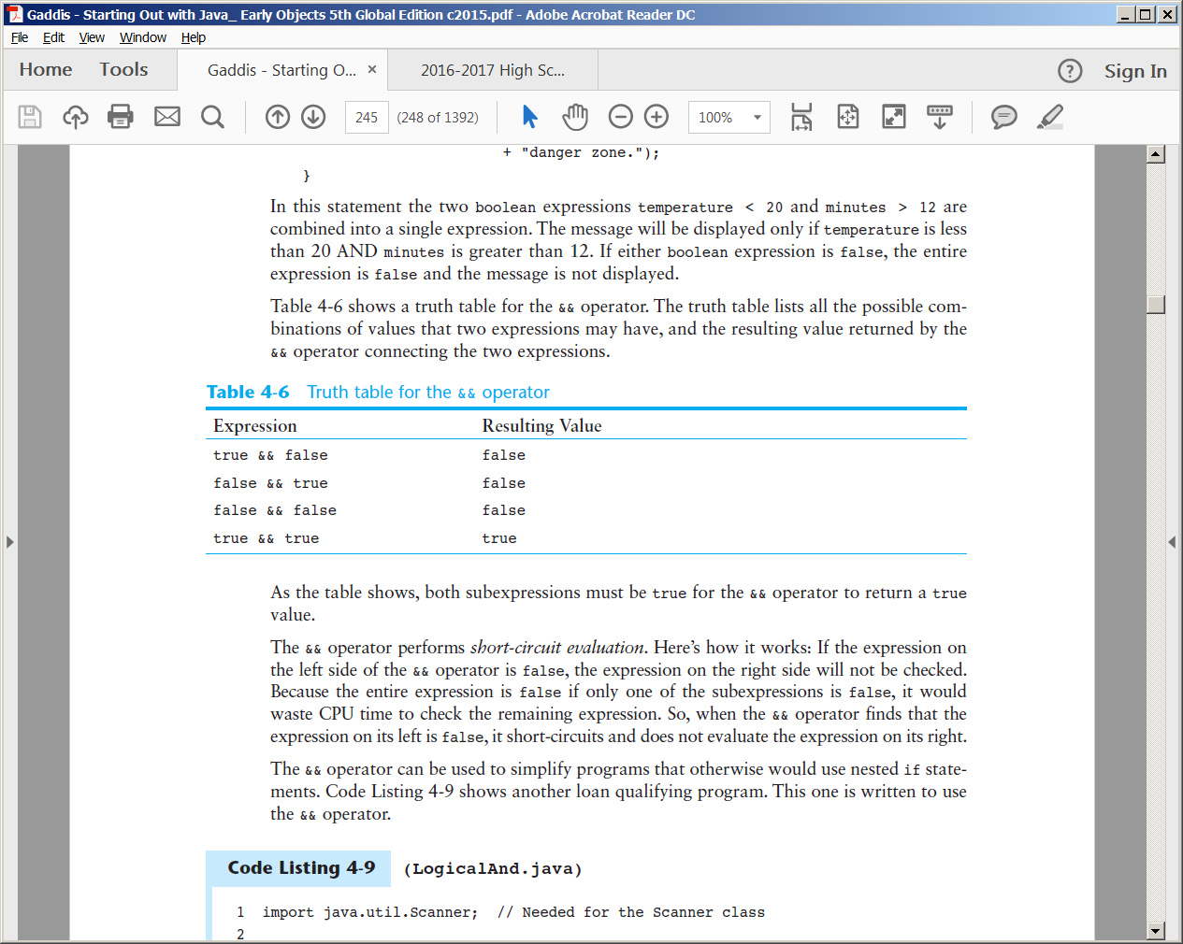**Logical Operators  
The && Operator**The && operator is known as the logical AND operator. It takes two boolean expressions as operands and creates a boolean expression that is true only when both subexpressions are true.

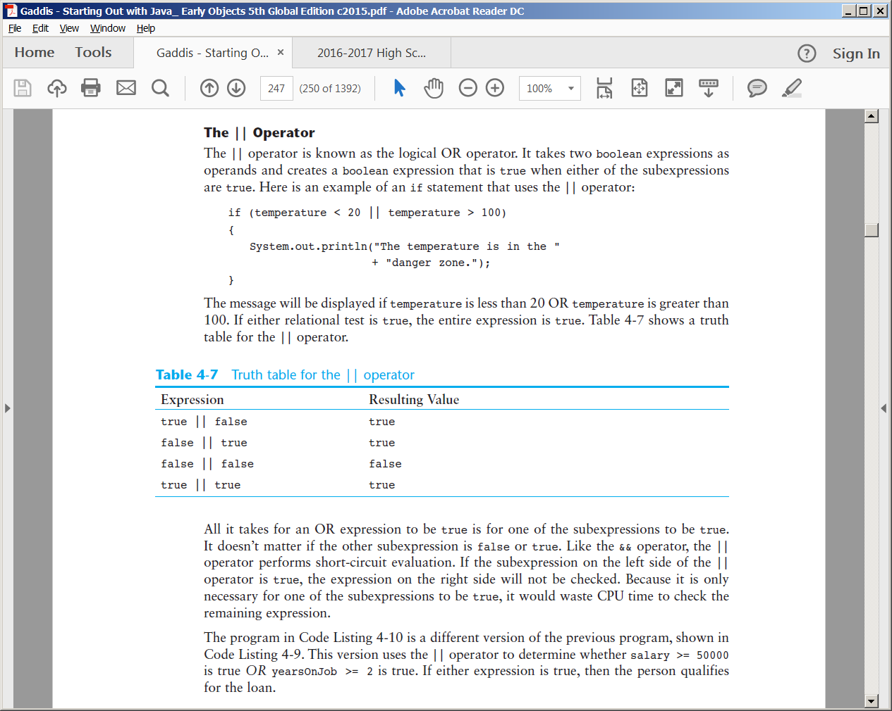

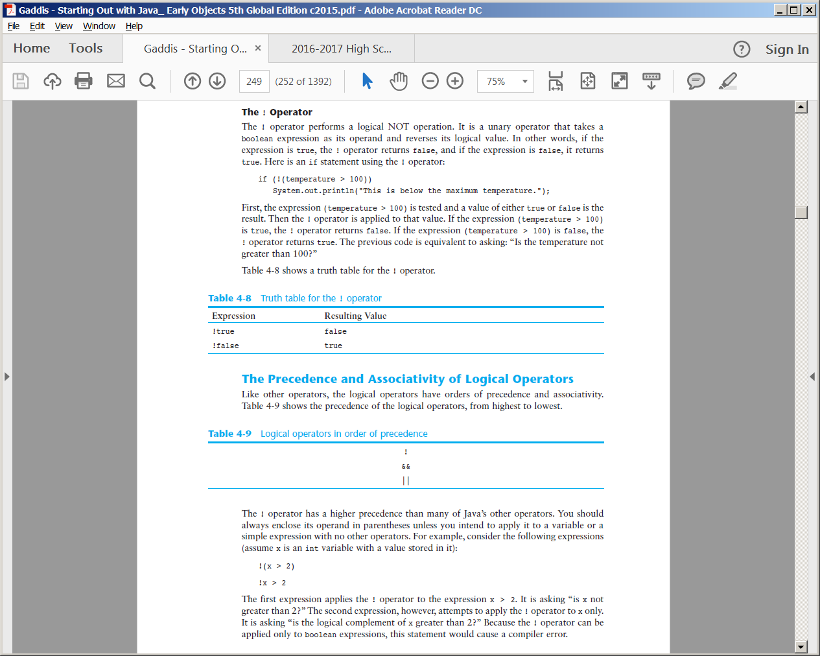

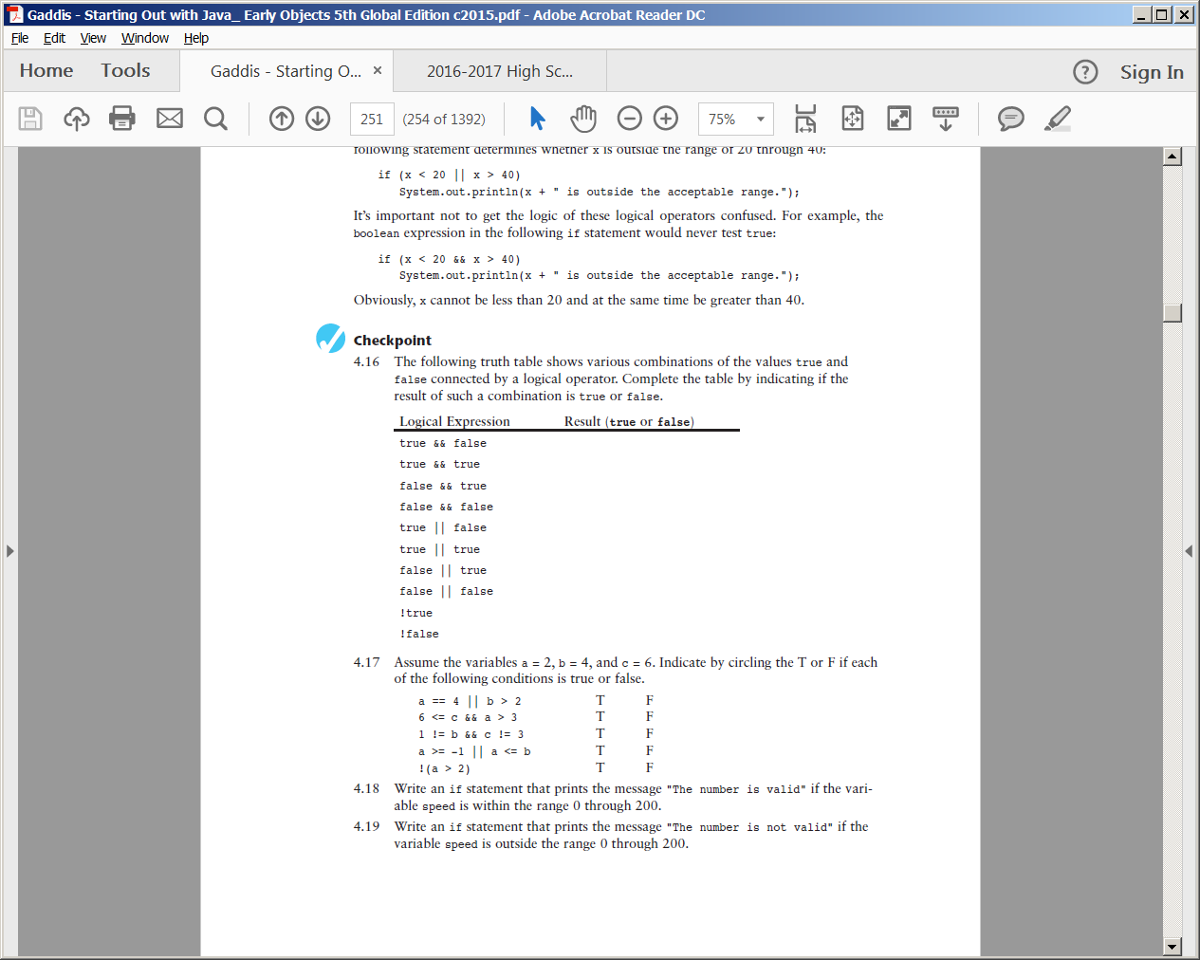

False  
True  
False  
False  
True  
True  
True  
False  
False   
True

|  |  |
| --- | --- |
| Logical Operators Short-Circuit Evaluation | |
| Operators | Resulting Value |
| && (AND) | False |
| || (OR) | True |

Determine True or False after the following statements, given the following variable declarations…

int a = 5;

int b = 6;

1.(a < b) && (a != b)

2.(b <= a) || (a != b)

3.(a >= b) || (a == b)

4.(a < b) && (a >= b)

5.((a <= b) || (a == b)) && (b > a)

6.(a <= b) || ((a == b) && (b > a))

7.!(a < b)

8.!(a == b) || (a >= b)

9.!((a != b) || (b >= a)) && (a <= b)

10.((a != b) || (b >= a)) && ((a <= b) || (a == b))